**Beet Seed**

Bug 1: When rotating the mobile device the banner on the top and the products categories and banners only appear in the middle of the screen and are small to read.

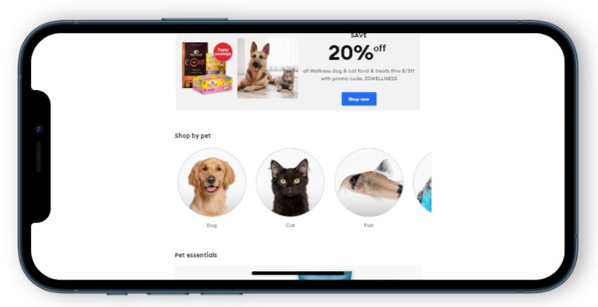

Bug 2: When a phone number is entered in the right format (xxx-xxx-xxxx) on “Create my Account” form a message error still appears: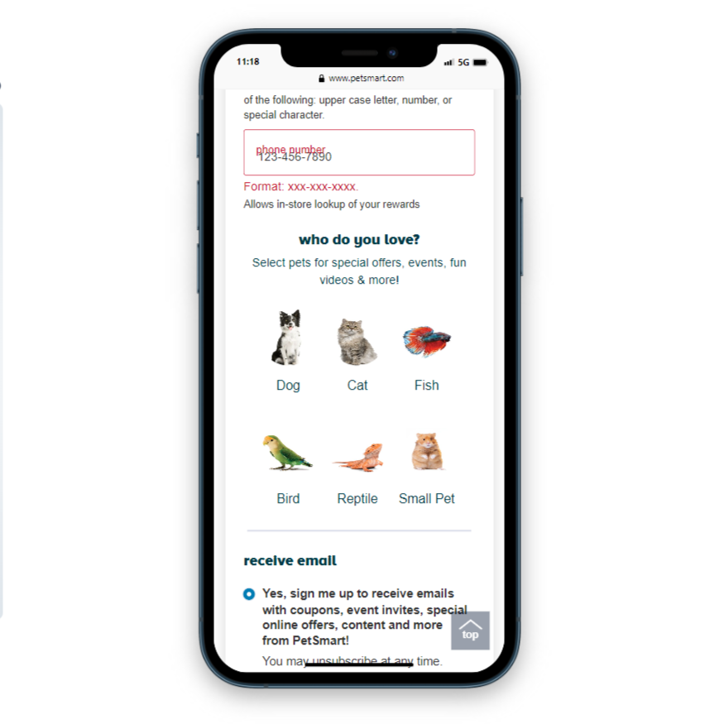

Bug 3: On trying to purchased the Advantage II Over 9 lbs Cat Flea Prevention & Treatment (<https://www.petsmart.com/cat/flea-and-tick/advantage-ii-over-9-lbs-cat-flea-prevention-and-treatment-23292.html?cgid=200208&fmethod=Browse>) the user cannot add to the cart any units in the option Ship to Me - a error on the “Add to Cart” button appears:



Bug 4: There is a typo on the “Save 20% off banner”:

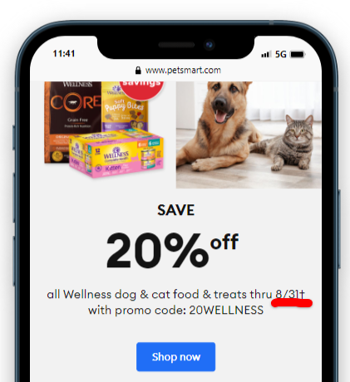

Bug 5: When clicking “Enable accessibility” on top on the home page nothing happens:

